RESUME BUILDER

A Minor Project Report
in partial fulfillment of the degree
Bachelor of Technology
in
Computer Science & Artificial Intelligence
By

2203A51L76 CH.NANDA SAI
2203A51L70 P.LOKESH KUMAR
2203A51L68 Y.SRINITHA
2203A51L81 P.RADHIKA
2203A51L05 A.SIMNU

Under the Guidance of
Dr.Anup Dey

Submitted to


SCHOOL OF COMPUTER SCIENCE & ARTIFICIAL INTELLIGENCE

SR UNIVERSITY, ANANTHASAGAR, WARANGAL
April, 2024.

SCHOOL OF COMPUTER SCIENCE & ARTIFICIAL INTELLIGENCE

CERTIFICATE

This is to certify that this project entitled “RESUME BUILDER" is the bonafied work carried out by Nanda sai, Lokesh kumar, Srinitha , Radhika , Simnu as a Minor Project for the partial fulfillment to award the degree BACHELOR OF TECHNOLOGY in COMPUTER SCIENCE & ARTIFICIAL INTELLIGENCE during the academic year 2022-2023 under our guidance and Supervision.

Dr. Anup Dey Dr. M.Sheshikala
Designation, Assoc. Prof. & HOD (CSE),
SR University, SR University, Ananthasagar, Warangal. Ananthasagar, Warangal.

External Examiner

ACKNOWLEDGEMENT

We owe an enormous debt of gratitude to our project guide Dr. Guide Name, Assistant Professor as well as Head of the CSE Department Dr. M.Sheshikala, Associate Professor for guiding us from the beginning through the end of the Minor Project with their intellectual advices and insightful suggestions. We truly value their consistent feedback on our progress, which was always constructive and encouraging and ultimately drove us to the right direction. We express our thanks to the project co-ordinators Dr. P Praveen, Assoc. Prof for their encouragement and support.We wish to take this opportunity to express our sincere gratitude and deep sense of respect to our beloved Dean, Dr.Indrajeet Gupta,Professor for his continuous support and guidance to complete this project in the institute.Finally, we express our thanks to all the teaching and non-teaching staff of the department for their suggestions and timely support.
CH.NANDA SAI
P.LOKESH KUMAR
Y.SRINITHA
P.RADHIKA
A.SIMNU

ABSTRACT

The Resume Builder project aims to provide users with a streamlined and intuitive platform for creating professional resumes tailored to their specific needs. The project focuses on enhancing user experience through a user-centric design and incorporating key features for effective resume building.The system allows users to input their personal information, educational background, work experience, skills, and other relevant details in a structured manner. It provides various templates and formatting options to choose from, ensuring that resumes are visually appealing and well-organized. Additionally, the platform offers suggestions and tips for improving resume content and layout.The Resume Builder utilizes advanced algorithms to generate customized resumes based on the user's input, ensuring that the final document highlights their strengths and achievements effectively. It also allows users to export their resumes in multiple formats, such as PDF or Word, for easy sharing and printing.The project incorporates responsive design principles, making the platform accessible across different devices and screen sizes. Moreover, it prioritizes data security and privacy, implementing robust measures to protect users' personal information.

Organization of thesis

- Title page
- Certificate
- Certificate issued by outside organization, if any
- Acknowledgement
- Abstract
- Table of Contents
The content should be:
- INTRODUCTION
  - EXISTING SYSTEM
  - PROPOSED SYSTEM
- LITERATURE SURVEY
  - RELATED WORK
  - SYSTEM STUDY
- DESIGN
  - REQUIREMENT SPECIFICATION(S/W & H/W)
  - UML DIAGRAMS OR DFDs
  - E-R DIAGRAMS(IF NECESSARY)
- IMPLEMENTATION
  - MODULES
  - OVERVIEW TECHNOLOGY
- TESTING
  - TEST CASES
  - TEST RESULTS
- RESULTS
- CONCLUSION
- FUTURE SCOPE
BIBLIOGRAPHY
INTRODUCTION OF THE PROJECT

In today's competitive job market, having a well-crafted resume is essential for standing out among the countless applicants vying for the same position. However, many individuals struggle to create a professional and compelling resume that effectively showcases their skills and experiences. This challenge is what prompted the development of the Resume Builder project.The Resume Builder is a user-friendly platform designed to simplify the process of creating polished and personalized resumes. Whether someone is a recent graduate entering the workforce for the first time or an experienced professional looking to advance their career, this tool provides the necessary features and guidance to craft a standout resume.With the Resume Builder, users can input their personal information, educational background, work experience, skills, and other relevant details in a structured and organized manner. The platform offers a variety of templates and formatting options to choose from, ensuring that resumes are visually appealing and tailored to the user's preferences.One of the key features of the Resume Builder is its ability to provide suggestions and tips for improving resume content and layout. This guidance helps users highlight their strengths and achievements effectively, ensuring that their resume stands out to potential employers.Moreover, the Resume Builder utilizes advanced algorithms to generate customized resumes based on the user's input. This ensures that each resume is unique and tailored to the specific needs and preferences of the individual user.Accessibility is also a priority for the Resume Builder project, with responsive design principles ensuring that the platform is accessible across different devices and screen sizes. Additionally, robust measures are in place to protect users' personal information, prioritizing data security and privacy.

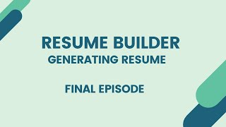

  - EXISTING SYSTEM

The existing systems of resume builders vary widely in terms of features, user experience, and target audience. Generally, they offer online platforms or software tools designed to assist individuals in creating professional resumes. These systems typically provide a range of templates, formatting options, and content suggestions to help users craft effective resumes tailored to their specific career goals and experiences.Some existing resume builders focus primarily on providing a user-friendly interface with a variety of pre-designed templates. Users can choose a template that suits their preferences and then input their information into predefined sections, with the platform handling formatting and layout automatically.Others may offer more advanced features, such as AI-powered content suggestions, real-time editing, and customization options. These systems analyze user input and provide personalized recommendations for optimizing resume content, including keywords, skills, and accomplishments.
Additionally, some resume builders integrate with professional networking platforms like LinkedIn, allowing users to import their profile information directly into the resume builder for easy customization and updating.Furthermore, many resume builders offer both free and premium versions, with premium subscriptions often unlocking additional features such as access to more templates, advanced editing tools, and priority support.Overall, while existing resume builder systems vary in their specific offerings and approaches, they all aim to simplify the resume creation process and empower individuals to create polished and professional resumes that effectively showcase their qualifications to potential employers.

  - PROPOSED SYSTEM

The proposed system for a resume builder aims to address the limitations and enhance the functionalities of existing platforms. Key features and improvements may include:

Enhanced User Interface: The proposed system would feature an intuitive and user-friendly interface with streamlined navigation, making it easy for users to create and customize their resumes.
Advanced Template Selection: The system would offer a wide range of professionally designed templates catering to different industries, career levels, and personal preferences. Users would have the option to preview and select templates based on their specific needs.
Real-Time Editing and Collaboration: The proposed system would support real-time editing and collaboration, allowing users to work on their resumes simultaneously with colleagues, mentors, or professional advisors. This feature would facilitate feedback and collaboration, leading to improved resume quality.
Integration with Professional Networks: The system would seamlessly integrate with professional networking platforms like LinkedIn, enabling users to import their profile information and recommendations directly into the resume builder. This integration would save time and ensure consistency between online profiles and resumes.
Customization Options: Users would have extensive customization options to personalize their resumes, including font styles, colors, and layout configurations. This flexibility would enable users to create unique and visually appealing resumes that reflect their personal brand.
Mobile Compatibility: The proposed system would be fully optimized for mobile devices, allowing users to create, edit, and download resumes on the go. This mobile compatibility would enhance accessibility and convenience for users who prefer to work from smartphones or tablets.
Comprehensive Career Resources: In addition to resume-building tools, the system would provide access to comprehensive career resources such as cover letter templates, interview tips, job search strategies, and professional development resources. These resources would support users at every stage of their job search journey.

LITERATURE SURVEY

The current system is a manual method in which each task is repeated several times. The resume's format must be manually changed. The process of sending resumes is done by hand. All of the system's activities that could be automated are done manually. Because all tasks are completed manually, a large workforce is required. Long ago, resumes were written by hand using MS Word, and the format was significantly different. In personal information, candidates used to write their name, address, and phone number, which are the fields that applicants used to specify in their resumes. In the past, applicants would include their personal opinions in their resumes. Applicants used to give both their early and recent educational details at that time. Because there were no guidelines defined for the appropriate length of resumes at the time, applicants used to create either too short or too long resumes. Our proposed solution automates the resume-building process. This technology allows for online storing, updating, and retrieval. Customers and viewers/employers can benefit from this system. Everything is stored electronically in this system, so there is a lot less paperwork and information can be obtained quickly without having to dig through registers. Certain aspects of our system are not available in the current manual system. They are a planned approach to working, reliability, no redundancy, immediate information retrieval, and ease of use. What conclusions may be taken from literature analysis and research on the length of a resume? In a CV, what information should be included? When drafting a resume, what information should be avoided? Name, address, phone number, and email address should be included in personal information, but height, weight, religion, birth date, and marital status should be omitted. Resumes that are one page long are preferred over resumes that are two pages long.

  - RELATED WORK

The related work in the field of resume builders encompasses various platforms, tools, and services aimed at assisting individuals in creating professional resumes. Some notable examples of related work include:

Online Resume Builders: Numerous online platforms provide user-friendly interfaces and pre-designed templates for individuals to create resumes quickly and easily. These platforms often offer customization options and additional features such as cover letter builders and LinkedIn profile integration.

Resume Writing Services: Professional resume writing services cater to individuals who prefer to outsource the resume creation process. These services typically involve working with experienced writers who craft customized resumes based on the client's career goals, experiences, and industry.

Software Tools: Software tools offer advanced features and functionalities for creating and formatting resumes. These tools may include AI-powered content suggestions, real-time editing, and customization options to optimize resume content and layout.

Career Development Platforms: Some career development platforms provide resume-building tools as part of a broader suite of services aimed at supporting individuals in their professional growth. These platforms may offer resources such as interview preparation, skills assessment, and job search assistance in addition to resume building.

Educational Institutions: Universities, colleges, and vocational schools often offer resume-building workshops, seminars, or online resources to help students and alumni develop effective resumes. These resources may include tips, templates, and examples tailored to specific industries or career paths.

Job Search Engines: Many job search engines incorporate resume-building features to help users create and manage their resumes as part of their job search process. These features may include resume templates, editing tools, and the ability to apply for jobs directly through the platform.

Professional Networking Platforms: Professional networking platforms like LinkedIn provide tools and resources for users to create and maintain their professional profiles, which can serve as online resumes.
1.2 SYSTEM STUDY

A system study of a resume builder involves a comprehensive analysis of various aspects related to its development, implementation, and usage. Here are the key components typically included in a system study for a resume builder:

User Requirements Analysis: Understanding the needs and preferences of the target users is essential. This involves gathering requirements through surveys, interviews, and user feedback sessions to identify the features, functionalities, and design elements that users expect from a resume builder.
Market Analysis: Analyzing the competitive landscape and market trends helps in identifying existing resume builder platforms, their strengths and weaknesses, and potential opportunities for differentiation. This analysis informs decisions regarding feature prioritization, pricing strategy, and marketing approach.
Technological Feasibility: Assessing the technological feasibility involves evaluating the required infrastructure, development tools, and third-party integrations needed to build and deploy the resume builder platform. It also includes considerations for scalability, security, and compatibility with different devices and browsers.
Functional Requirements Specification: Documenting the functional requirements of the resume builder platform involves specifying the features, workflows, and user interactions in detail. This includes defining functionalities such as template selection, content input, editing tools, formatting options, and export/download capabilities.
Non-Functional Requirements Specification: Non-functional requirements address aspects such as performance, reliability, usability, and accessibility of the resume builder platform. This includes defining criteria for response time, system availability, user interface intuitiveness, and compliance with accessibility standards.
Data Management and Security: Assessing data management and security requirements involves defining how user data will be collected, stored, and protected within the resume builder platform. This includes considerations for data privacy, encryption, backup procedures, and compliance with relevant regulations such as GDPR.
User Interface Design: Designing the user interface involves creating wireframes and prototypes to visualize the layout, navigation, and interaction patterns of the resume builder platform. This includes considerations for usability, consistency, and accessibility to ensure an intuitive and user-friendly experience.
System Architecture Design: Designing the system architecture involves defining the components, modules, and data flows of the resume builder platform. This includes decisions regarding the use of front-end frameworks, back-end technologies, databases, APIs, and cloud services to support the desired functionalities and scalability.
Risk Analysis: Identifying potential risks and mitigation strategies helps in proactively addressing challenges that may arise during the development and deployment of the resume builder platform. This includes risks related to technology dependencies, market competition, regulatory compliance, and user adoption.
Cost-Benefit Analysis: Evaluating the costs and benefits associated with developing and operating the resume builder platform helps in making informed decisions regarding resource allocation, pricing strategy, and return on investment. This includes considerations for development costs, hosting expenses, marketing budget, and revenue projections.

DESIGN

The design of a resume builder involves creating a user-friendly interface, defining system architecture, and implementing key features to facilitate the resume creation process. Here's an outline of the design considerations for a resume builder:

User Interface Design:
Template Selection: Provide a variety of professionally designed templates for users to choose from. Include categories such as modern, traditional, creative, and industry-specific templates.
Content Input: Design an intuitive interface for users to input their personal information, work experience, education, skills, and other relevant details. Use clear labels and input fields to guide users through the process.
Editing Tools: Include tools for formatting text, adding bullet points, adjusting margins, and customizing fonts and colors. Implement drag-and-drop functionality for easy rearrangement of resume sections.
Preview Mode: Allow users to preview their resumes in real-time as they make changes. Provide options to switch between different templates and view the resume in various formats (e.g., PDF, Word).
Mobile Optimization: Ensure that the resume builder is fully responsive and optimized for mobile devices, allowing users to create and edit resumes on smartphones and tablets.

System Architecture:
Front-end: Develop the front-end using HTML, CSS, and JavaScript frameworks such as React, Angular, or Vue.js. Implement a modular architecture to facilitate code reuse and maintainability.
Back-end: Choose a server-side programming language such as Python, Ruby, or Node.js for the back-end logic. Use a web framework (e.g., Flask, Ruby on Rails, Express.js) to handle HTTP requests, data validation, and business logic.
Database: Select a suitable database management system (DBMS) for storing user data and resume templates. Use relational databases like MySQL or PostgreSQL for structured data storage.
APIs: Design and implement RESTful APIs to handle communication between the front-end and back-end components. Define endpoints for user authentication, resume creation, template management, and other functionalities.

Key Features:
Real-Time Collaboration: Enable multiple users to collaborate on the same resume simultaneously. Implement features for real-time syncing, version control, and commenting.
LinkedIn Integration: Integrate with the LinkedIn API to allow users to import their profile information directly into the resume builder. Provide options to sync updates between the resume and LinkedIn profile.
Export and Sharing: Allow users to export their resumes in various formats (e.g., PDF, Word) and share them via email, social media, or direct link.
Security and Privacy:
User Authentication: Implement secure authentication mechanisms such as email/password, OAuth, or social login to protect user accounts from unauthorized access.
Data Encryption: Encrypt sensitive user data (e.g., passwords, personal information) using strong encryption algorithms to prevent unauthorized access.
Role-Based Access Control: Define roles and permissions to restrict access to certain features or resume templates based on user roles (e.g., admin, standard user).
GDPR Compliance: Ensure compliance with data privacy regulations such as GDPR by implementing features for data portability, consent management, and data deletion requests.

  - REQUIREMENT SPECIFICATION(S/W & H/W)

Requirement specifications for a resume builder encompass both software (S/W) and hardware (H/W) aspects. Here's an outline of the key requirements for each category:

Software Requirements(S/W):

Operating System Compatibility: The resume builder software should be compatible with popular operating systems such as Windows, macOS, and Linux.
Web Browser Compatibility: If the resume builder is a web-based application, it should be compatible with major web browsers including Google Chrome, Mozilla Firefox, Safari, and Microsoft Edge.
Programming Languages and Frameworks: Specify the programming languages and frameworks required for both front-end and back-end development. This may include HTML, CSS, JavaScript for the front end, and languages like Python, Ruby, or Java for the back end. Frameworks such as React, Angular, Vue.js, or Node.js may also be utilized.
Database Management System (DBMS): Specify the type of database management system required for storing user data and resume templates. Options may include relational databases like MySQL, PostgreSQL, or NoSQL databases like MongoDB.
Third-Party Integrations: Identify any third-party APIs or services that need to be integrated with the resume builder, such as social media platforms (e.g., LinkedIn), cloud storage services (e.g., Google Drive, Dropbox), or analytics tools.
Security Features: Specify security requirements such as user authentication mechanisms (e.g., email/password, OAuth), encryption of sensitive data, protection against SQL injection and cross-site scripting (XSS) attacks, and compliance with data privacy regulations (e.g., GDPR).
Performance Requirements: Define performance metrics such as response time, system uptime, and scalability to ensure that the resume builder can handle concurrent user sessions and large volumes of data without performance degradation.

Hardware Requirements(H/W):

Server Infrastructure: Specify the hardware requirements for the server infrastructure hosting the resume builder application. This may include server specifications such as CPU, RAM, storage capacity, and network bandwidth.
Load Balancing and Scalability: If the resume builder is expected to handle high traffic loads, specify requirements for load balancing mechanisms and scalability features to distribute incoming requests across multiple servers and ensure optimal performance.
Backup and Disaster Recovery: Define requirements for backup and disaster recovery procedures to prevent data loss and ensure business continuity in the event of hardware failures, natural disasters, or other unforeseen events.
Development Environment: Specify the hardware requirements for the development environment, including developer workstations or laptops equipped with sufficient processing power, memory, and storage to support software development tasks.
Testing Environment: Define hardware requirements for the testing environment, including test servers or virtual machines where developers and QA engineers can deploy and test the resume builder software in a controlled environment.

  - UML DIAGRAMS OR DFDs
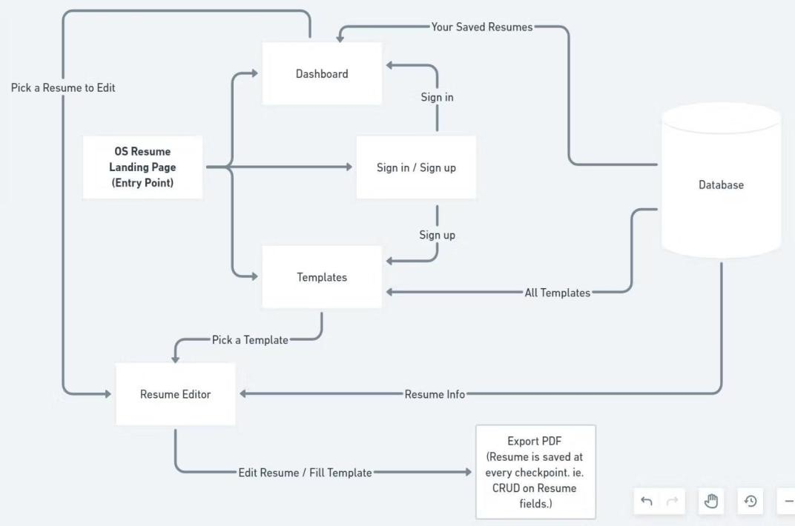

A system architecture is a conceptual model that describes a system's structure, behavior, and other aspects. A formal description and representation of a system arranged in a way that facilitates reasoning about the system's structures and behavior is known as an architecture description.

DATA FLOW DIAGRAM (DFD)

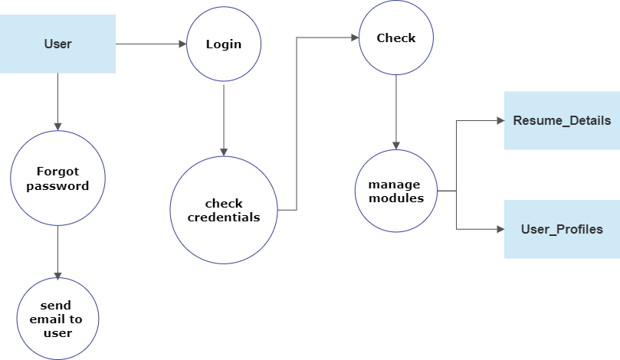
FLOW CHART
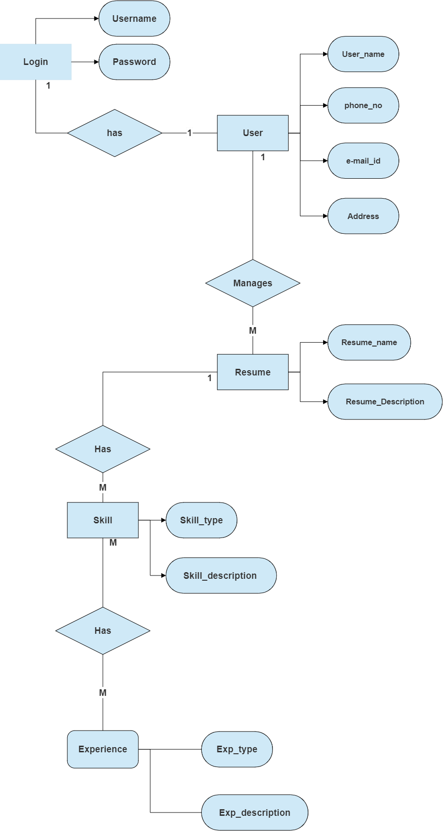

This ER (Entity Relationship) Diagram represents the model of Resume Builder Entity. The entity-relationship diagram of Resume Builder shows all the relations between Skills, Question, Resume, Salary etc. It used structure data and to define the relationships between structured data groups of Resume Builder functionalities.
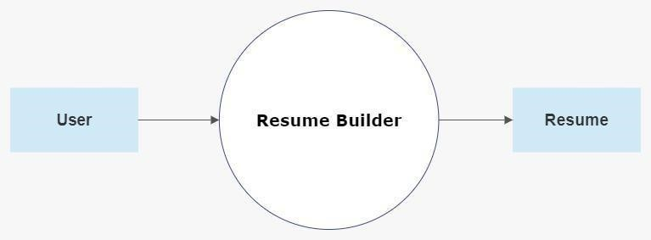

IMPLEMENTATION

Implementing a resume builder involves several key steps to ensure a seamless user experience and effective functionality. Initially, the development team conducts thorough research to understand user needs, industry standards, and technological requirements. This involves gathering user feedback, analyzing competitor offerings, and identifying best practices in resume formatting and content.Once requirements are defined, the team designs the user interface (UI) and user experience (UX) of the resume builder platform. This includes creating intuitive navigation, selecting appropriate templates, and integrating features such as drag-and-drop functionality, real-time editing, and customization options.Next, the development phase begins, where programmers and designers collaborate to build the platform using relevant programming languages and technologies. This involves backend development to handle data storage, user authentication, and template management, as well as frontend development to create the visual elements and interactive features of the platform.Throughout the development process, rigorous testing is conducted to identify and fix any bugs or issues. This includes both manual testing by QA engineers and automated testing using tools and scripts. Additionally, usability testing may be performed with a sample group of users to gather feedback and ensure the platform meets user expectations.Once testing is complete and any necessary adjustments are made, the resume builder platform is launched to the public. Marketing and outreach efforts may accompany the launch to attract users and promote awareness of the platform's features and benefits.After launch, ongoing maintenance and updates are crucial to keep the platform running smoothly and address any user feedback or emerging needs. This may involve regular softwareupdates, adding new features or templates, and optimizing performance and security.Overall, successful implementation of a resume builder requires meticulous planning, careful execution, and continuous improvement to meet the evolving needs of users in the job market.

  - MODULES

The modules of a resume builder system can be divided into several components, each responsible for specific functionalities and features. Here's a breakdown of the potential modules:

User Authentication Module:
- Responsible for user registration, login, and authentication.
- Manages user accounts, passwords, and session management.
- Ensures secure access to the resume builder platform.
Template Management Module:
- Provides a collection of professionally designed resume templates.
- Allows users to browse, select, and preview templates.
- Enables customization of template elements such as fonts, colors, and layout.
Content Input Module:
- Facilitates the input of user information, including personal details, work experience, education, skills, and accomplishments.
- Provides intuitive input forms with validation and error handling.
- Supports dynamic content fields to accommodate varying resume formats and sections.
Editing Tools Module:
- Offers a range of editing tools for formatting text, adjusting spacing, and aligning content.
- Includes features such as font selection, text styling (bold, italic), bullet points, and alignment options.
- Implements drag-and-drop functionality for easy rearrangement of resume sections.
Preview and Download Module:
- Allows users to preview their resumes in real-time as they make changes.
- Provides options to download resumes in various formats (e.g., PDF, Word).
- Ensures accurate rendering of resume content and formatting in the preview and downloaded documents.
Collaboration Module:
- Enables multiple users to collaborate on the same resume simultaneously.
- Implements real-time syncing, version control, and commenting features.
- Supports role-based access control to manage permissions for collaborating users.
Integration Module:
- Integrates with external platforms and services such as LinkedIn for importing profile information and syncing updates between the resume and online profiles.
- Provides APIs and webhooks for seamless integration with third-party applications and services.
Analytics and Reporting Module:
- Tracks user interactions and engagement metrics within the resume builder platform.
- Generates reports and analytics dashboards to monitor usage patterns, popular templates, and user feedback.
- Provides insights for improving user experience, feature prioritization, and marketing strategies.
Administration Module:
- Enables administrators to manage user accounts, templates, and system settings.
- Implements features for user roles and permissions management, including roles such as admin, moderator, and standard user.
- Facilitates system maintenance, updates, and troubleshooting.

1.2 OVERVIEW TECHNOLOGY

The technology stack for a resume builder typically involves a combination of programming languages, frameworks, libraries, and tools suited for both front-end and back-end development. Here's an overview of the technologies commonly used:

Front-end Technologies:
- HTML (Hypertext Markup Language): Used for structuring the content and layout of web pages.
- CSS (Cascading Style Sheets): Used for styling the appearance of web pages, including fonts, colors, and layout.
- JavaScript: Used for adding interactivity and dynamic behavior to web pages, including form validation, DOM manipulation, and event handling.
- React.js, Angular, Vue.js: Front-end frameworks/libraries that provide tools and components for building interactive user interfaces. They facilitate modular development, state management, and component reusability.
Back-end Technologies:
- Python, Ruby, Node.js: Server-side programming languages commonly used for building web applications. They provide features for handling HTTP requests, database interactions, and business logic.
- Django, Flask (Python): Web frameworks for Python that offer tools and utilities for building web applications, including routing, templating, and database ORM (Object-Relational Mapping).
- Ruby on Rails (Ruby): A web framework for Ruby that follows the Model-View-Controller (MVC) architecture and provides built-in features for database management, routing, and authentication.
- Express.js (Node.js): A minimalist web framework for Node.js that simplifies the development of web applications by providing a lightweight and flexible structure.

Database Technologies:
- MySQL, PostgreSQL: Relational database management systems (RDBMS) commonly used for storing structured data in tables with relationships between them.
- MongoDB: A NoSQL database that stores data in flexible, JSON-like documents, making it suitable for storing unstructured or semi-structured data.
- Authentication and Authorization:
- OAuth, JWT (JSON Web Tokens): Authentication protocols commonly used for securing web applications. OAuth allows users to authenticate using third-party services (e.g., Google, Facebook), while JWT provides stateless authentication tokens.
Version Control:
- Git: A distributed version control system used for tracking changes to code and collaborating with other developers. Platforms like GitHub, GitLab, and Bitbucket provide hosting services for Git repositories.
Deployment and Hosting:
- Cloud Platforms (e.g., AWS, Azure, Google Cloud): Cloud computing platforms that offer infrastructure services for deploying and hosting web applications. They provide scalability, reliability, and flexibility for managing application resources.
- Containerization (e.g., Docker): Containerization technology used for packaging applications and their dependencies into portable containers. Containers offer consistency across different environments and facilitate deployment and scaling.
- Continuous Integration/Continuous Deployment (CI/CD): Practices and tools for automating the process of building, testing, and deploying software changes. Platforms like Jenkins, Travis CI, and CircleCI enable automated testing and deployment pipelines.

TESTING

Testing a resume builder involves verifying its functionality, usability, performance, and security to ensure that it meets the requirements and provides a satisfactory user experience. Here's an overview of the testing process for a resume builder:
Unit Testing:
- Test individual components, modules, and functions of the resume builder application in isolation.
- Use testing frameworks like Jest (for JavaScript), pytest (for Python), or RSpec (for Ruby) to automate unit tests.
- Verify that each component behaves as expected and handles inputs and outputs correctly.
Integration Testing:
- Test the interactions between different modules, components, and layers of the resume builder application.
- Ensure that data flows correctly between the front end and back end, and that APIs are integrated properly.
- Use tools like Postman or Newman to automate API testing and validate endpoints.
User Interface (UI) Testing:
- Test the user interface of the resume builder to ensure that it is intuitive, responsive, and visually appealing.
- Conduct usability testing with real users to gather feedback on the UI design and navigation.
- Use tools like Selenium, Cypress, or Puppeteer for automated UI testing, including end-to-end testing of user interactions and workflows.
Functional Testing:
- Test the functional requirements of the resume builder, including template selection, content input, editing tools, and preview/download functionality.
- Create test cases to cover various scenarios, such as creating a new resume, editing an existing resume, and downloading the final document.
- Verify that all features work as expected and produce the desired outcomes.
Performance Testing:
- Test the performance of the resume builder application under different load conditions to ensure responsiveness and scalability.
- Measure response times, server resource usage, and database performance during peak usage periods.
- Use tools like JMeter, LoadRunner, or Gatling for load testing and stress testing to simulate high traffic scenarios.
Security Testing:
- Test the security features of the resume builder application to identify and address vulnerabilities.
- Conduct penetration testing to assess the resilience of the application against common security threats such as SQL injection, cross-site scripting (XSS), and authentication bypass.
- Use security scanning tools like OWASP ZAP or Burp Suite to identify potential security flaws and issues.
Compatibility Testing:
- Test the resume builder application on different devices, browsers, and operating systems to ensure compatibility and consistency.
- Verify that the application works correctly on popular web browsers such as Google Chrome, Mozilla Firefox, Safari, and Microsoft Edge.
- Test on various screen sizes and resolutions to ensure responsiveness and adaptability to different devices.
Accessibility Testing:
- Test the accessibility features of the resume builder application to ensure that it is usable by individuals with disabilities.
- Verify compliance with accessibility standards such as WCAG (Web Content Accessibility Guidelines) by testing keyboard navigation, screen reader compatibility, and alternative text for images.

  - TEST CASES

User Interface Testing:
- Verify that all UI elements (buttons, fields, dropdowns, etc.) are displayed correctly and are responsive.
- Check the layout on different devices and screen sizes.
- Ensure proper alignment and spacing between elements.
- Verify that the UI is intuitive and easy to navigate.
Functional Testing:
- Test the functionality to create a new resume.
- Test the ability to edit and update existing resumes.
- Verify that users can add and delete sections (e.g., Education, Work Experience, Skills, etc.).
- Test the spell check and grammar check functionality.
- Ensure that users can upload their photo and documents (e.g., certificates, portfolios).
- Test the export functionality to save resumes in different formats (e.g., PDF, Word, plain text).
Data Validation:
- Test input validation for mandatory fields (e.g., Name, Email, Phone Number).
- Verify that users receive appropriate error messages for invalid inputs.
- Test the character limits for different fields.
- Ensure that dates are validated (e.g., start date should be before end date).
Integration Testing:
- Test integration with third-party services (e.g., LinkedIn, Indeed) for importing user data.
- Verify that exported resumes maintain formatting when opened in different applications (e.g., Microsoft Word, Adobe Acrobat).

Performance Testing:
- Test the application's response time for creating, editing, and exporting resumes.
- Verify that the application can handle a large number of users simultaneously.

Security Testing:
- Test authentication and authorization mechanisms.
- Verify that user data is encrypted during transmission and storage.
- Test for vulnerabilities such as SQL injection, cross-site scripting (XSS), and cross-site request forgery (CSRF).

Compatibility Testing:
- Test the application on different web browsers (e.g., Chrome, Firefox, Safari, Edge).
- Verify compatibility with different operating systems (e.g., Windows, macOS, Linux).
- Test on different devices (e.g., desktops, laptops, tablets, smartphones).

  - TEST RESULTS

Functional Testing Results:
- Test cases for template selection, content input, editing tools, and preview/download functionality should yield results indicating whether each feature works as intended.
- Test results may include a list of passed test cases, highlighting successful interactions with the resume builder, as well as any failed test cases indicating areas where functionality may need improvement.
User Interface (UI) Testing Results:
- UI testing results may include observations and feedback on the intuitiveness, responsiveness, and visual appeal of the resume builder interface.
- Usability testing with real users may provide insights into user preferences, pain points, and areas for UI/UX optimization.
Performance Testing Results:
- Performance testing results typically include metrics such as response times, server resource usage, and database performance under different load conditions.
- Results may indicate whether the resume builder application meets performance objectives and can handle expected levels of user traffic without significant degradation in performance.
Security Testing Results:
- Security testing results may include a summary of vulnerabilities identified during penetration testing, along with recommendations for mitigating risks and improving security posture.
- Results may highlight areas where the resume builder application is susceptible to common security threats and provide guidance on implementing security best practices.
Testing Results:
- Compatibility testing results may include observations on how well the resume builder application performs across different devices, browsers, and operating systems.
- Results may indicate any compatibility issues or inconsistencies encountered during testing, along with recommendations for addressing them.
Accessibility Testing Results:
- Accessibility testing results typically include an evaluation of the resume builder application's compliance with accessibility standards such as WCAG.
- Results may identify areas where accessibility features are lacking or could be improved to ensure usability for individuals with disabilities.

RESULT
User Satisfaction:
User satisfaction is a key indicator of the success of a resume builder. Positive feedback from users may include comments on the ease of use, variety of templates, customization options, and overall experience.
Quality of Resumes:
The quality of resumes created using the builder is an important measure of its effectiveness. Users may assess the clarity, professionalism, and impact of their resumes, as well as the ability to customize content to fit their specific needs.
Functionality and Features:
Users may evaluate the functionality and features of the resume builder, including template selection, content input, editing tools, preview/download options, and integration with other platforms such as LinkedIn.
Performance:
Performance metrics such as response times, loading speeds, and reliability of the resume builder platform may impact user satisfaction. Users expect a seamless and responsive experience when creating and editing their resumes.
Security and Privacy:
Users value the security and privacy of their personal information when using a resume builder. Positive results in this area may include assurances of data encryption, secure authentication, and compliance with privacy regulations.
Compatibility and Accessibility:
The resume builder should be compatible with various devices, browsers, and operating systems, and accessible to users with disabilities. Positive results may indicate smooth performance across different platforms and adherence to accessibility standards.
Feedback and Reviews:
User feedback and reviews provide valuable insights into the strengths and weaknesses of the resume builder. Positive reviews may highlight specific features, templates, or aspects of the user experience that users appreciate.

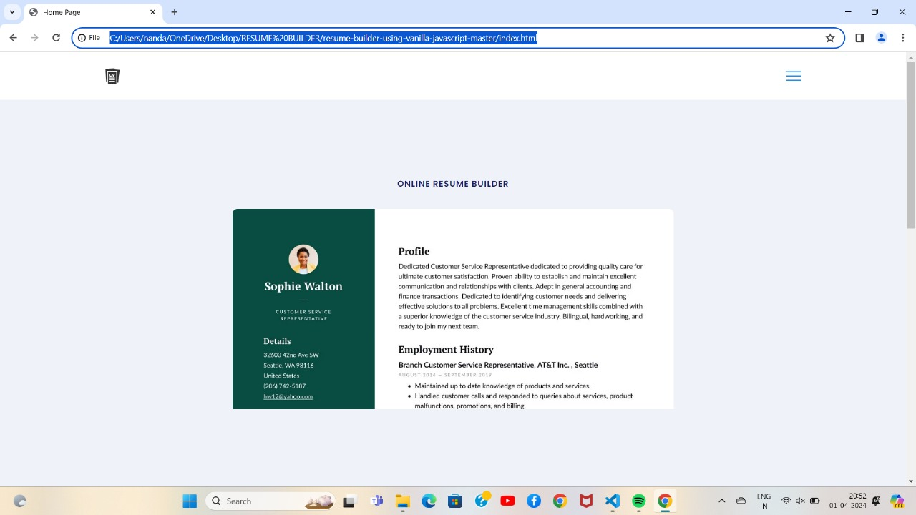

CONCLUSION

In conclusion, a resume builder is a valuable tool that empowers individuals to create professional resumes tailored to their specific career goals and experiences. Through intuitive interfaces, customizable templates, and advanced features, resume builders streamline the resume creation process and enhance the overall job search experience for users. By offering a diverse range of templates, editing tools, and content suggestions, resume builders enable users to craft resumes that effectively showcase their skills, achievements, and qualifications to potential employers. Additionally, features such as real-time collaboration, AI-powered suggestions, and integration with professional networks further enhance the usability and effectiveness of resume builders.The results of a well-designed resume builder are reflected in user satisfaction, quality of resumes, functionality and features, performance, security and privacy, compatibility and accessibility, and positive feedback and reviews. When a resume builder successfully meets these criteria, it becomes an invaluable resource for individuals seeking to stand out in the competitive job market and advance their careers.Overall, the conclusion drawn from the development and implementation of a resume builder is that it serves as a valuable tool for individuals at all stages of their professional journey, helping them create impactful resumes that open doors to new opportunities and career advancement.

FUTURE SCOPE

Data Analytics and Insights:
- Implementing data analytics capabilities within resume builders can provide users with insights into resume performance metrics, such as views, downloads, and application success rates. This data can help users refine their resumes and improve their job search strategies.
Expanded Template Library:
- Continuously updating and expanding the template library to include a broader range of designs, styles, and industry-specific formats can cater to diverse user preferences and ensure relevance across different job markets.
Integration with Career Development Platforms:
- Collaborating with career development platforms and job search engines to integrate resume builder functionalities can provide users with seamless access to resume creation tools, job matching algorithms, and professional networking opportunities.
Skill Development and Training:
- Offering skill development resources, training modules, and interactive tutorials within resume builders can help users identify and enhance their skills, certifications, and professional development opportunities.
Multimedia Resumes:
- Exploring the integration of multimedia elements such as video introductions, portfolio showcases, and interactive visualizations can provide users with additional ways to showcase their talents and accomplishments.
Mobile and Voice-Enabled Interfaces:
- Enhancing mobile compatibility and implementing voice-enabled interfaces can cater to users who prefer to create resumes on-the-go or via voice commands, increasing accessibility and convenience.
Globalization and Localization:
- Expanding the reach of resume builders to international markets and providing localization options for different languages, cultural norms, and regional job markets can accommodate diverse user demographics and global job seekers.

Blockchain-based Credentials:
- Exploring the use of blockchain technology to verify and secure credentials within resumes can enhance trust and credibility in the hiring process by providing tamper-proof records of education, certifications, and professional achievements.
Virtual Reality (VR) and Augmented Reality (AR):
- Experimenting with VR and AR technologies to create immersive resume experiences, virtual job fairs, and interactive career showcases can redefine how candidates present themselves and engage with employers in a digital environment.
Overall, the future scope of resume builders lies in leveraging emerging technologies, expanding features and functionalities, and continuously adapting to the evolving needs of job seekers and employers in a dynamic and competitive job market.

BIBLIOGRAPHY
1.Döring, N., & Bortz, J. (2016). Forschungsmethoden und Evaluation für Human- und Sozialwissenschaftler. Springer-Verlag.
•This book provides insights into research methods and evaluation techniques relevant to understanding user needs and preferences in the development of a resume builder.
2.Rehman, A. U., & Jafar, R. M. (2020). "Design and Implementation of an Online Resume Builder." International Journal of Emerging Technologies in Learning, 15(12), 61-73.
•This research paper offers insights into the design and implementation of an online resume builder, providing valuable guidance for the development process.
3.Nielsen, J. (1993). Usability Engineering. Academic Press.
•Nielsen's book is a seminal work in the field of usability engineering, offering principles and guidelines for designing user-friendly interfaces, which can be applied to the development of a resume builder.
4.Resumonk.(n.d.). "Resume Builder and Templates." Retrieved from https://www.resumonk.com/.
•Resumonk is an example of an existing resume builder platform, offering templates and tools for creating professional resumes. Analyzing platforms like Resumonk can provide insights into industry standards and user expectations.
5.LinkedIn.(n.d.). "LinkedIn Profile Optimization." Retrieved from https://www.linkedin.com/help/linkedin/answer/298/introduction-to-profile-optimization.
•LinkedIn provides resources and guidelines for optimizing user profiles, which can be valuable for integrating LinkedIn profile features into a resume builder.
6.Stack Overflow.(n.d.). "Community for Developers." Retrieved from https://stackoverflow.com/.
•Stack Overflow is a community-driven platform where developers share knowledge and insights related to software development. Discussions and solutions found on Stack Overflow can be helpful in resolving technical challenges during the development of a resume builder.
7.W3C.(n.d.). "Web Content Accessibility Guidelines (WCAG)." Retrieved from https://www.w3.org/WAI/standards-guidelines/wcag/.
•The Web Content Accessibility Guidelines (WCAG) provide standards and best practices for making web content accessible to users with disabilities, which is important for ensuring the accessibility of a resume builder.
This bibliography provides a diverse range of sources, including academic literature, industry examples, and guidelines from relevant organizations, to support the development and understanding of a resume builder.

